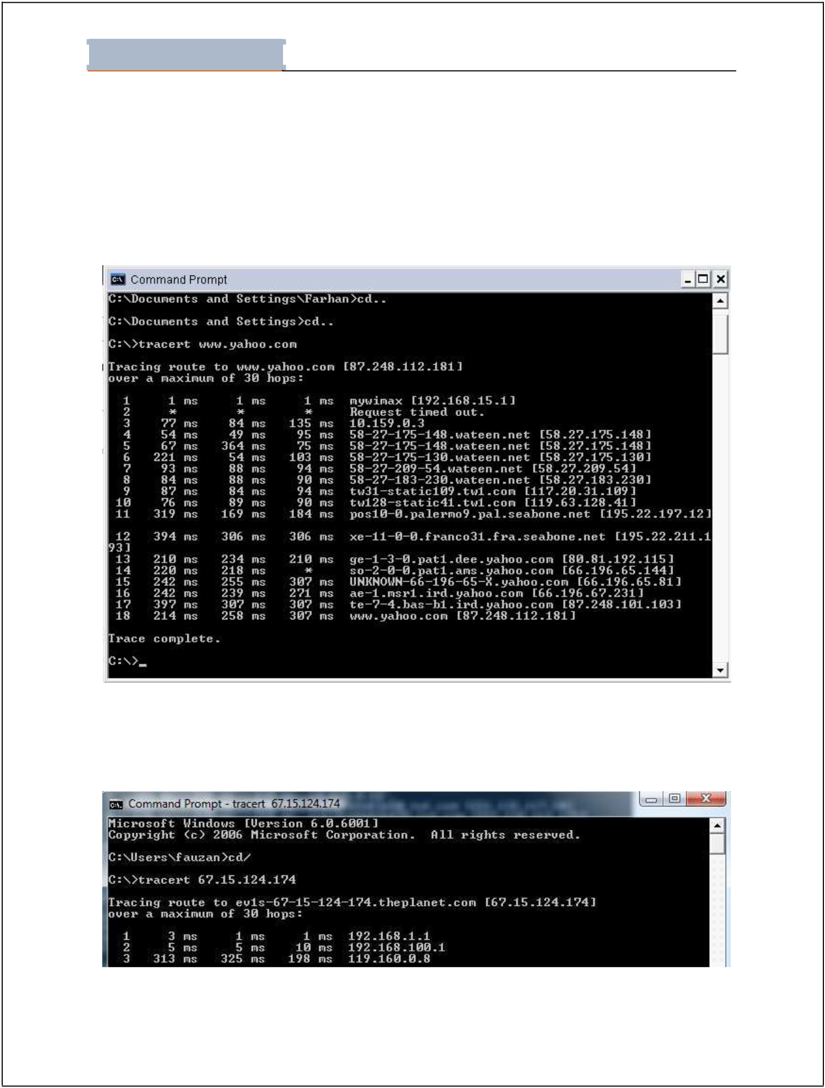
Lab - 01

Student Name: Fahama Khan Roll No: 19B-039-CS Section: ”A”

LAB # 01: TCP/IP UTILITIES

1. Tracert

Tracert is a utility that can be used to determine the route and hop count to a destinatio n.
Example of tracert is shown below:

Figure 1. Tracert

You can use IP Address instead of Domain Name

Figure 2. Tracert with Domain Name

Page 1 of 11
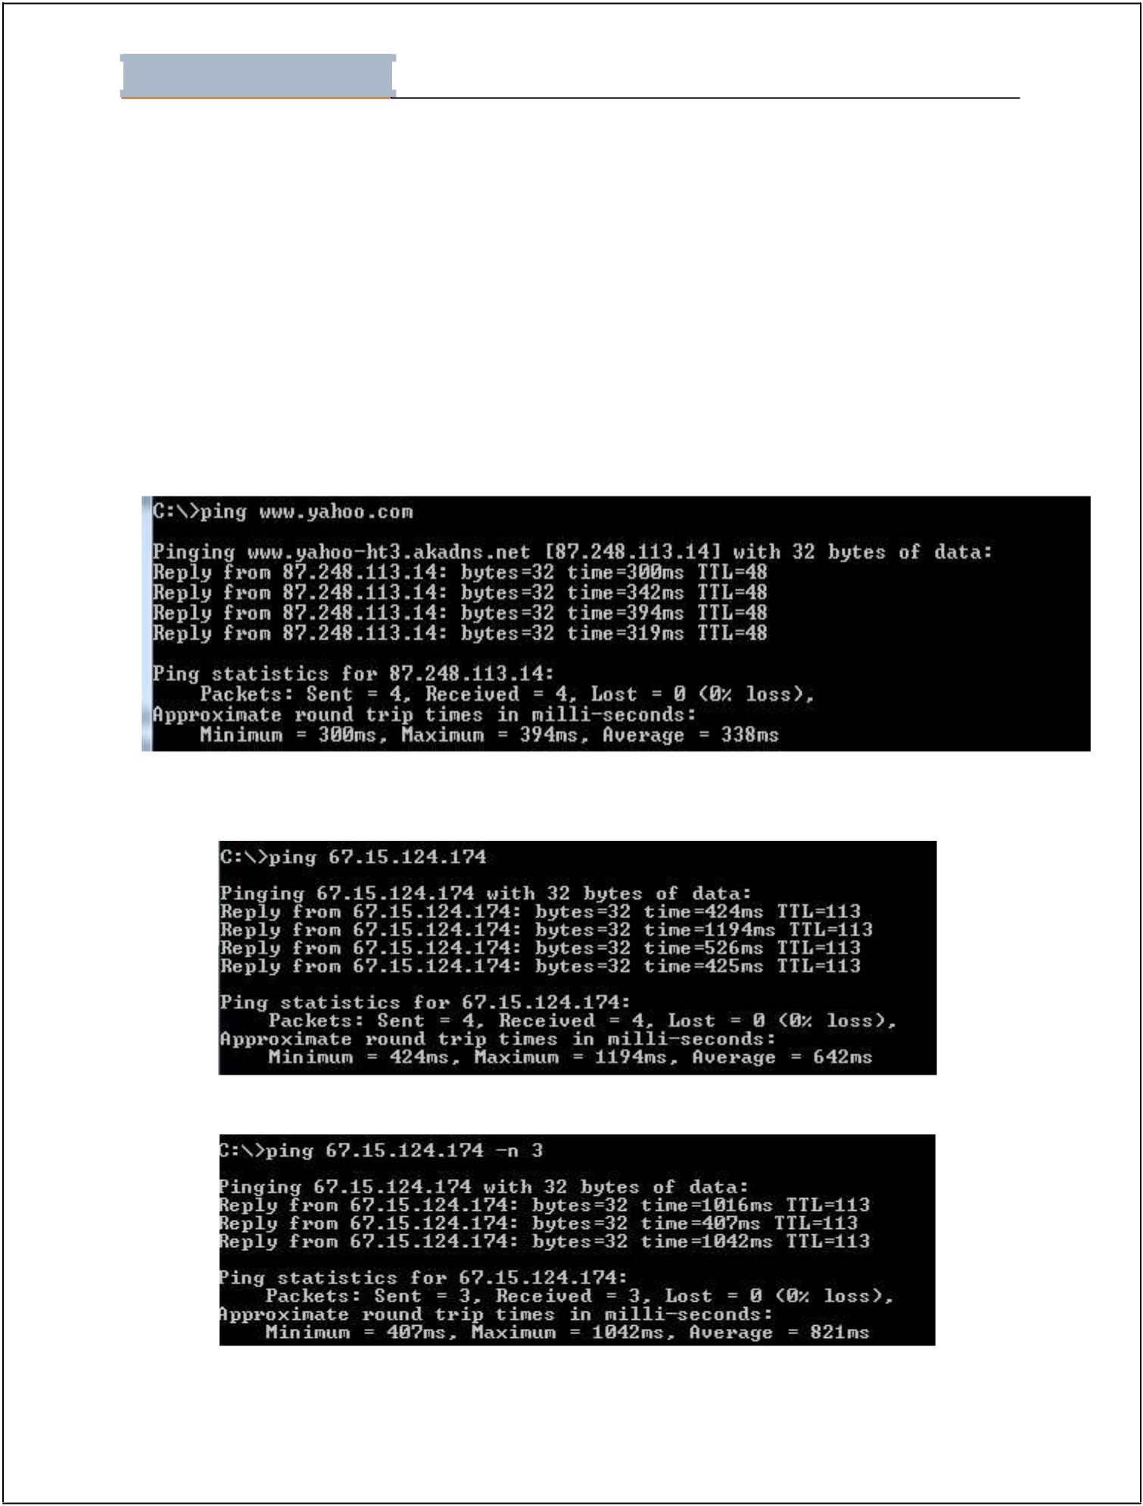
Lab - 01

Student Name: ________________________________Roll No: __________________ Section:__________

2. PING

PING stands for “Packet Internet Groper” and it is a diagnostic tool that is used to check whether a host is reachable or not. Target can be either a name or IP address.

Syntax:

Ping www.uit.edu

Ping ip address (you can mention ip address instead of domain name)

Ping ip address or Domain name –n number of packets you want to sent

Ping –a ip address.(will first resolve ip to its domain name)

Figure 3. Ping with Domain Name

Figure 4. Ping with IP

Figure 5. Ping -n

Page 2 of 11
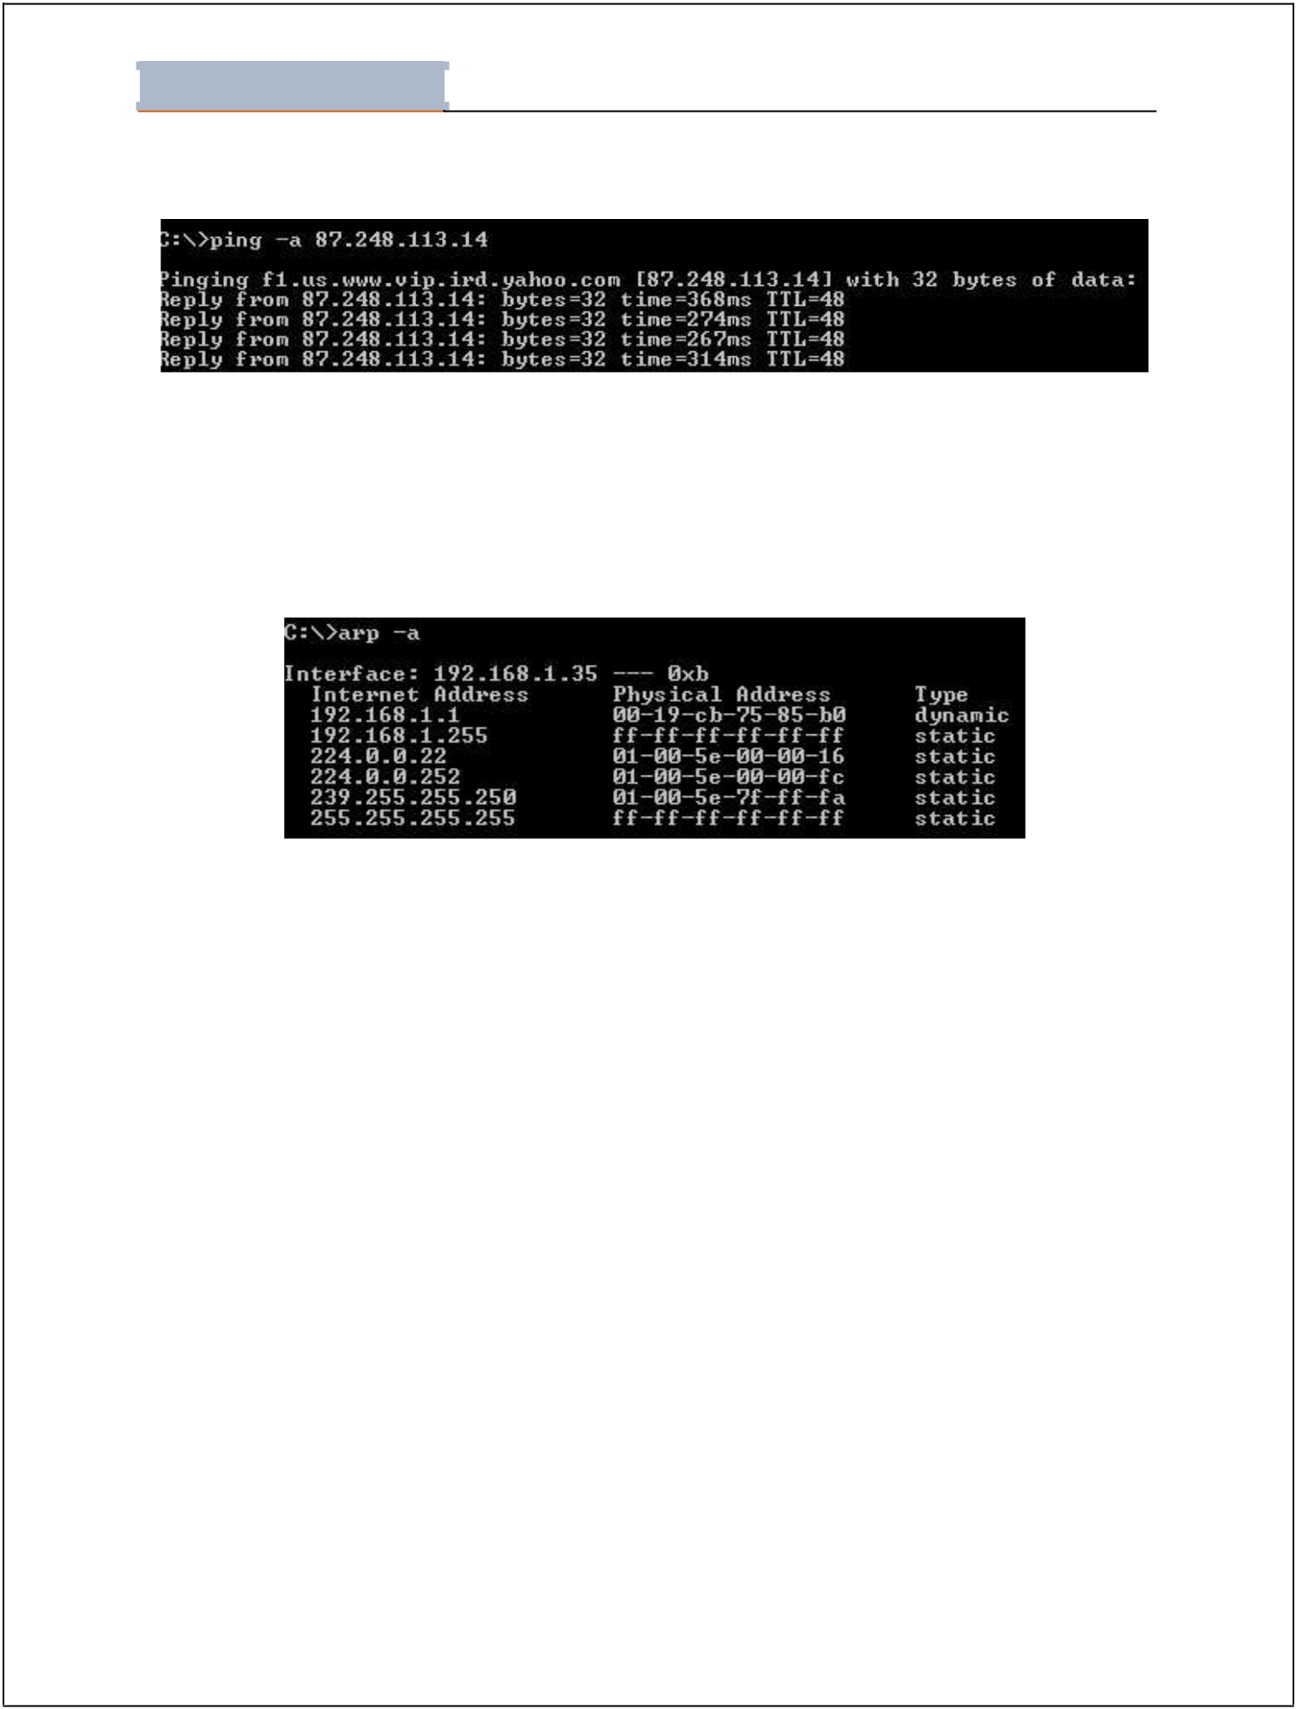
Lab - 01

Student Name: ________________________________Roll No: __________________ Section:__________

Figure 6. Ping -a

3. ARP

ARP is “Address Resolution Protocol”. It is used to resolve IP address to MAC address.

arp –a (will show a list of relevant IP addresses and their corresponding MAC addresses)

Figure 7. Arp

We can also set a MAC address against an IP address through the following command

arp –s ip address MAC address

4. Nslookup

Nslookup utility is used to test and troubleshoot domain name servers. Nslookup has two modes. Interactive mode enables you to query name servers for information about hosts and domains, or to print a list of hosts in a domain. Non- interactive mode prints only the name and requested details for one host or domain. Non-interative mode is useful for a single query.

To enter the interactive mode of Nslookup, type nslookup without any arguments at a command prompt, or use only a hypen as the first argument and specify a domain name server in the second. The default DNS name server will be used if you don't enter anything for the second argument.

Page 5 of 11
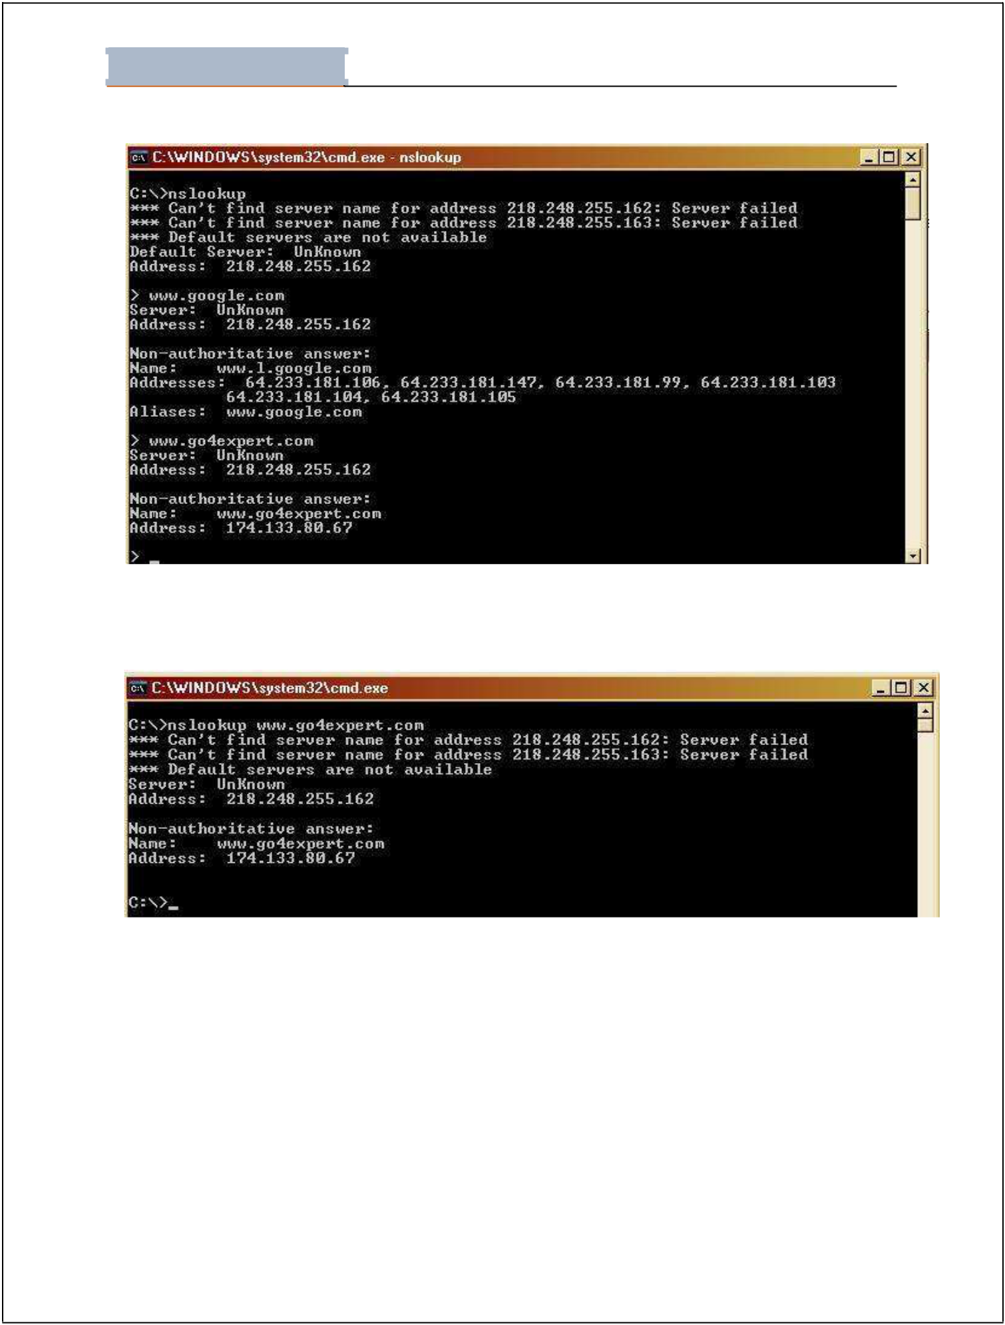
Lab - 01

Student Name: ________________________________Roll No: __________________ Section:__________

Figure 11. Nslookup

To use non-interactive mode, in the first argument, enter the name or IP address of the computer you want to look up. In the second argument, enter the name or IP address of a domain name server. The default DNS name server will be used if you don't enter anything for the second argument.

Figure 12. Nslookup with Domain Name

(note:- nslookup works equally well in unix.)

Page 6 of 11
Lab - 01

Student Name: ________________________________Roll No: __________________ Section:__________

5. Ftp

Transfers files to and from a computer running a File Transfer Protocol (FTP) server service such as Internet Information Services. Ftp can be used interactively or in batch mode by processing ASCII text files. Syntax

ftp [-v] [-d] [-i] [-n] [-g] [-s:FileName] [-a] [-w:WindowSize] [-A] [Host]

Parameters

-v : Suppresses the display of FTP server responses.

-d : Enables debugging, displaying all commands passed between the FTP client and FTP server.

-i : Disables interactive prompting during multiple file transfers.

-n : Suppresses the ability to log on automatically when the initial connection is made.

-g : Disables file name globbing. Glob permits the use of the asterisk (*) and question mark (?) as wildcard characters in local file and path names.

-s: FileName : Specifies a text file that contains ftp commands. These commands run automatically after ftp starts. This parameter allows no spaces. Use this parameter instead of redirection (<).

-a

: Specifies that any local interface can be used when binding the FTP data connection.

-w: WindowSize : Specifies the size of the transfer buffer. The default window size is 4096 bytes.

-A : Logs onto the FTP server as anonymous.

Host : Specifies the computer name, IP address, or IPv6 address of the FTP server to which to connect. The host name or address, if specified, must be the last parameter on the line.

/? : Displays help at the command prompt.


Lab - 01

Student Name: ________________________________Roll No: __________________ Section:__________

Do it Yourself

Task 01: Explore the syntax “ipconfig” and “winipcfg”. Note down your observations?
Answer:
Ipconfig is a DOS utility used from MS-DOS and the Windows command line to display the network settings which is assigned and given by a network. This command can be utilized to verify a network connection as well as to verify network settings. On the other hand winipcfg command allows a user to get network related information like the IP address, subnet mask, default gateway, DHCP server, WINS server etc.

Task 02: Answer following questions

- State the size of MAC address both in Bytes and Bits.

Answer:

The size of Mac address is 6 bytes and 48 bits.

- Differentiate between IP and MAC address

Answer:
Mac Address:
MAC Address stands for Media Access Control Address.
it is the physical address of the computer and it's unique.
MAC Address can be retrieved using ARP protocol.
MAC Address is of six byte hexadecimal address.

IP Address:
IP Address stands for Internet Protocol Address.
IP Address is a logical address of the computer and is used to uniquely locate computer connected via a network.
IP Address can be retrieved using RARP protocol.
IP Address is of 4 bytes or of 16 bytes.

- What is a gateway?
Answer:
Gateway is a hardware device that acts as a gate between the two networks, and it’s connected with nodes. It may be router, firewall, server and other traffic flow.

- What is the purpose of loop-back address?
Answer:
The loopback address takes into consideration a solid strategy for testing the usefulness of an Ethernet card and its drivers and programming without an actual organization. It likewise permits data innovation experts to test IP programming without agonizing over broken or tainted drivers or equipment.

- PING stands for “Packet Internet Groper”.

- What is the difference between ipconfig and ipconfig/all commands?
Answer:
ipconfig stands for Internet Protocol Configuration. This command is used to view all the current TCP/IP network configurations values of the computer. It is used in Windows operating system.

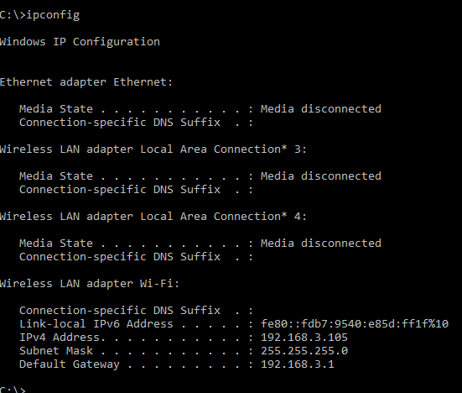

ifconfig stands for Interface Configuration. This command is the same as ipconfig and is used to view all the current TCP/IP network configurations values of the computer. Is mainly used in Open source operating system like Linux, Ubuntu etc.

- What is Nslookup stands for? What is the significance of this utility? What is Non-authoritative answer?
Answer:
Nslookup:
It is stands for Name server loopup basically, it is popular, and it is used to query a DNS server for resource records a domain. This tool is used for troubleshooting DNS or name resolution issue with the help of DNS server or the list of DNS servers in the IP settings can be used.
Non-authoritative answer:
The output of nslookup, you will notice the statement "non-authoritative answer" as part of the lookup result. This is to tell you know that the results were provided by a server that is not the authoritative (primary) source. Typically, this means the result was provided by a server (such as your Internet service provider) that held a cached copy of the DNS record. This is important because the DNS record may have been changed recently and the cached copy may not reflect the most up-to-date information.

C:\>nslookup www.facebook.com
Server: UnKnown
Address: 192.168.3.1
Non-authoritative answer:
Name: star-mini.c10r.facebook.com
Addresses: 2a03:2880:f10c:181:face:b00c:0:25de
157.240.15.35
Aliases: www.facebook.com

Write a command to transfer “abc.txt” file from PC having IP address.
192.168.2.21 to PC having IP address 192.168.100.1. Also write a command to get the same file from the PC having IP address 192.168.100.1

